**Sarathi Weraduwage**

Research Assistant Professor

Sharkey Lab member

Representative of the MSU-DOE PRL to the College of Natural Science Diversity Equity and Inclusion Advisory Committee (DEIAC)

My research focuses on exploring the signaling pathway of isoprene and its physiological role in plants. Isoprene a volatile hydrocarbon produced in large amounts by some plants, but not all plants. Isoprene is synthesized by the methylerythritol 4-phosphate (MEP) pathway and the conversion of dimethylallyl diphosphate to isoprene is catalyzed by isoprene synthase (ISPS). Isoprene enhances plant resilience to heat and oxidative stress, and herbivory, but the exact mechanism of action of isoprene is not fully understood. Isoprene emission is affected by environmental factors such as light, temperature and CO2; isoprene emission increases with high temperature and decreases with increasing CO2. Using Arabidopsis (a non-emitter in nature) transformed with a *Eucalyptus globulus* *ISPS*,we found that the regulatory mechanisms of photosynthesis and isoprene emission were similar to native emitters indicating that the regulation of isoprene emission is not specific to isoprene emitting species. Isoprene had a marked positive effect on growth in Arabidopsis. We also found that isoprene could alter expression of genes belonging to signaling networks of specific growth regulators that promotes growth or defense, and genes that are important for stress tolerance **(Figure 1)**. Our data reveled that isoprene probably executes its effects on growth and stress tolerance through direct effects on gene expression and support a novel role for isoprene as a signaling molecule. We are currently investigating the sequence of isoprene mediated signaling pathways in plants, and whether engineering non-native emitters to produce isoprene would enhance their growth and resilience to stress.

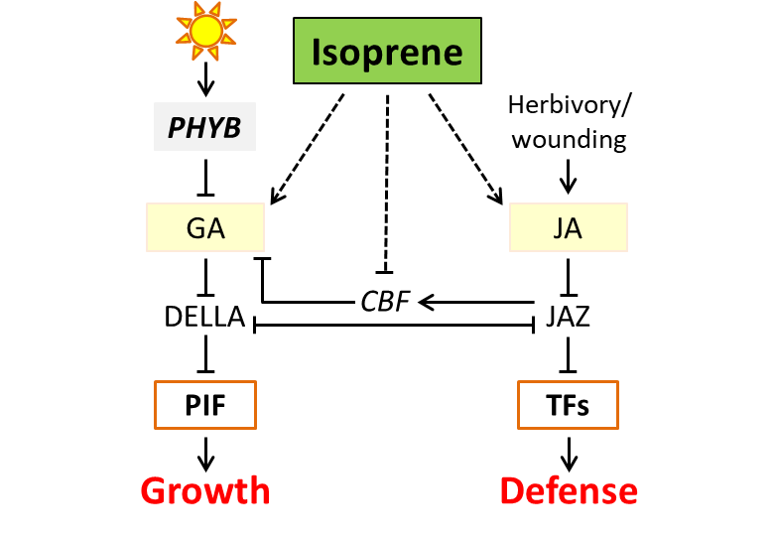

**Figure 1. Proposed model for how isoprene signaling can affect gibberellic acid-mediated growth and jasmonic acid-mediated defense responses**

As a member of the Department of Energy, Plant Research Laboratory (DOE-PRL), I also study the relationship between photosynthesis and plant growth specifically in the model plant *Arabidopsis*. In order to understand the relationship between photosynthesis and plant growth and the molecular mechanisms that alter this relationship, we developed the *Arabidopsis* Leaf Area Growth Model to model the flow of storage C and photosynthetic C from seed germination to leaf senescence while simulating the use of assimilated C in respiratory processes and the partitioning of the remaining C to leaf area growth and leaf thickening, root growth, and inflorescence growth. By investigating growth, C assimilation and partitioning in five sets of Arabidopsis mutant lines we found that although photosynthesis provides C for growth, changes in leaf architecture (thickness, area, mesophyll cell density) brought about by small changes in partitioning of assimilated C to leaf area growth and thickening, is sufficient to enhance overall plant growth. We showed that pectin methylation by pectin methyltranferases (*CGR2* and *CGR3)* directly affects this relationship between photosynthesis and plant growth by altering the degree cell expansion and/or adhesion thereby driving C partitioning by generating C demands for leaf area growth and leaf thickening. Given that optimization of leaf architecture is a necessity to maximize light interception, gas exchange properties and photosynthesis, I am interested in understanding molecular mechanisms and genes that affect cell wall properties and leaf architecture as a means to improve photosynthesis. So far we have shown that xyloglucan endotransglucosylase/hydrolase and pectin methyl transferase/pectin methylesterase/ pectin methylesterase inhibitor systems are key downstream execution points of leaf architectural changes common to different upstream molecular systems such as the salicylic, jasmonic and gibberellic acid signaling pathways.

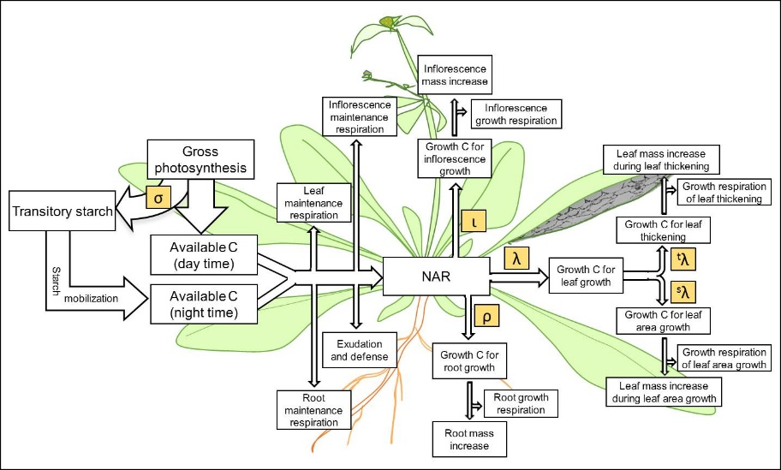

**Figure 2. The underlying scheme of C ﬂow represented in the Arabidopsis Leaf Area Growth Model**

Besides research, I serve as the representative of the PRL to the College of Natural Science Diversity Equity and Inclusion Advisory Committee (DEIAC). The PRL strives to achieve a “welcoming, nourishing and inclusive atmosphere that encourages creative exploration, collaboration, and scientific excellence” – The PRL Code of Ethics. By listening to ideas, suggestions and proposals from both the DEIAC and the PRL community, my role is to create a framework that will enhance effective communication amongst PRL members as well as enhance accessibility to information and resources to achieve the goals set forth by the PRL and the DEIAC. I also love teaching and mentoring. I taught PLB 416 - Plant Physiology Laboratory Course (2016) and served as a teaching assistant and guest lecturer for BMB 401 – Biochemistry (2017, 2018). I also participated as a mentor in the MSU Great Lakes Bioenergy Research Center Summer Undergraduate Research Program (2019) and the Plant Genomics at MSU - Research Experience for Undergraduates Program (2015, 2016). I also volunteer for outreach programs such as the MSU Fascination of Plants Day (2017, 2018).

Publications

* Lantz AT, Allman J, **Weraduwage SM**, Sharkey TD (2019) Isoprene: New insights into the control of emission and mediation of stress tolerance by gene expression. Plant Cell and Environment, 1– 19
* Lantz A, Solomon C, Gog L, McClain A, **Weraduwage SM**, Sharkey TD (2019) Isoprene suppression by CO2 is not due to triose phosphate utilization (TPU) limitation. Frontiers in Forests and Global Change e 2:8
* Soltani A, **Weraduwage SM**, Sharkey TD, Lowry DB (2019). Elevated temperatures cause loss of seed set potentially through the disruption of source-sink relationships. BMC genomics, 20:312.
* Li J, **Weraduwage SM**, Preiser AL, Weise SE, Strand DD, Froehlich JE, Kramer DM, Hu J, Sharkey TD (2019). Loss of peroxisomal hydroxypyruvate reductase inhibits triose phosphate isomerase but stimulates cyclic photosynthetic electron flow and the Glc-6p-phosphate shunt. Plant Physiology (Accepted).
* Zuo Z, **Weraduwage SM**, Lantz AT, Sanchez LM, Weise SE, Sharkey TD (2019). Expression of isoprene synthase in Arabidopsis alters plant growth and expression of key abiotic and biotic stress-related genes under unstressed conditions. Plant Physiology, 80:124–152
* Ren T, **Weraduwage SM**, Sharkey TD (2018) Prospects for enhancing leaf photosynthetic capacity by manipulating mesophyll cell morphology. Journal of Experimental Botany, 70: 1153-1165
* **Weraduwage SM**, Campos ML, Yoshida Y, Major I, Kim Y-S, Kim S-J, Renna L., Anozie FC, Brandizzi F, Thomashow MF, Howe GA, Sharkey TD (2018) Molecular Mechanisms Determining Leaf Architecture. In: Adams III W. W., Terashima I. (eds), The Leaf: A Platform for Performing Photosynthesis. Advances in Photosynthesis and Respiration (Including Bioenergy and Related Processes), vol 44. Springer, Cham
* Campos ML, Yoshida Y, Major I, Ferreira OD, **Weraduwage SM**, Froehlich JE, Johnson B, Jander G, Sharkey TD, Howe GE (2016). Rewiring of jasmonate and phytochrome signaling uncouples plant growth-defense tradeoffs. Nature Communications, 7, 12570.
* **WeraduwageSM**, Kim S-J, Renna L, Anozie FC, Sharkey TD, Brandizzi B (2016). Pectin Methylesterification Impacts the Relationship between Photosynthesis and Plant Growth in *Arabidopsis thaliana*. Plant Physiology, 171, 833-848.
* **Weraduwage SM**, Rauf SA, Micallef MC, Marillia E-F, Taylor DC, Grodzinski B and Micallef BJ (2016). Increased mtPDH activity through antisense inhibition of mitochondrial pyruvate dehydrogenase kinase enhances inflorescence initiation, and inflorescence growth and harvest index at elevated CO2 in *Arabidopsis thaliana*. Frontiers in Plant Science, 7, 95.
* **Weraduwage SM**, Chen J, Anozie FC, Morales A, Weise SE and Sharkey TD (2015). The relationship between leaf area growth and biomass accumulation in *Arabidopsis thaliana*. Front. Plant Sci. 6, 167.
* Keshav D, **Weraduwage SM**, Kane K, Rauf SA, Leonardos ED, Gadapati W, Savitch L, Singh J, Marillia E-F, Taylor DC, Micallef MC, Knowles V, Plaxton W, Barron J, Sarhan F, Hüner N,GrodzinskiB andMicallef BJ (2014) Theme 3a: Enhancing biomass production and yield by maintaining enhanced capacity for CO2 uptake in response to elevated CO2 . Canadian Journal of Plant Science, 94: 1075-1083.
* Leonardos ED, Rauf SA**, Weraduwage SM**, Marillia E-F, Taylor DC, Micallef BJ and Grodzinski B (2013). Photosynthetic capacity of the inflorescence is a major contributor to daily-C-gain and the responsiveness of growth to elevated CO2 in *Arabidopsis thaliana* with repressed expression of mitochondrial-pyruvate-dehydrogenase-kinase. [Environmental and Experimental Botany](http://www.sciencedirect.com/science/journal/00988472), 107: 84–97.
* **Weraduwage SM**, Micallef BJ, Grodzinski B, Taylor DC, and Marillia E-F (2011) Plant Systems: Roles of dark respiration in plant growth and productivity. In: Murray Moo-Young (ed.), Comprehensive Biotechnology, second edition, 4, 191–207. Elsevier.